Individual Teacher Technology Assessment Narrative
Tabitha Edmondson-Goodman
ITEC 7460 Professional Learning & Technology
Kennesaw State University
Ed.S. Instructional Technology, Fall 2016
Dr. Angela Bacon

Ms. Jones is a first grade teacher at A. L. Burruss Elementary School. I have had the privilege to work with her for the past two years as her gifted mentor and in our advanced content courses. She has two years of teaching experience, as she recently graduated from Wesleyan College in Macon, Georgia. She has taught both first and second grade, here in my school, as well as being team leader for her grade level. After working with her for the past two years I feel that I have built up a good relationship with her, so I encouraged her to complete my two technology questionnaires. The goal of my questionnaires was to probe her comfort level, understanding of integrating technology into her classrooms, and her vision for technology. Her classroom is equipped with a Smartboard, which is an integral part of her lessons to enhance student learning. Also, her classroom has a sound amplification unit, a laptop cart with twenty functioning laptops, three desk tops, a flip camera, and a document camera to increase student involvement and engagement in her student’s learning. Our school also offers two fully functioning computer labs. Each first grade classroom visits the computer lab once a week for their Compass Learning time as well as weekly check-out times in the media center.
Perspective of Technology
On the Technology Needs Assessment, Ms. Jones began by rating her overall skill in using educational technology as a beginner, but she consistently uses technology throughout her classroom. When I met with Ms. Jones to go over her survey and expand on some of her answers, she stated, “I use technology throughout my classroom to engage my students and to provide them with a variety of presentation modes, but my students are not using technology fully”. She is using technology regularly through emails, keeping track of data resources, behavior management systems, and to help support her lessons. She also indicated that she believed that technology is motivating and engaging our students. There are times that integrating technology can become challenging in her classroom. She stated, “In first grade we have the least desired laptops. We have the oldest and most broken. At times keys do not work and often things like Adobe is not updated. My kids are able to use technology fairly successfully and independent when it works, but they have no troubleshooting skills”.
In her survey she mentioned that her grade level supplements their student learning through individualized learning technology, videos, and music. Some programs and software that are used consistently are: RAZ Kids, Compass Learning, Math Facts in a Flash, Brainpop, Pebblego, Safari Montage, Discovery Education, and Bookflix. She does acknowledge that her students use technology mainly for remediation and practice. I was fairly surprised that given how much technology is used in her classroom that she did not have an opinion on the kind of professional development that she would like to attend. She stated, “I know that I need professional development to enhance my use of technology, but I’m not sure where to start. I know a little bit about a lot, but I would like to know a lot about a little bit”. She also identified that time plays a large factor in integrating technology into her lesson plans, which is something that all teachers struggle with. Lack of time impacts not only technology integration, but it also hinders our teachers from exploring and working through these resources.
Access to Technology
On the Technology Needs Assessment, Ms. Jones documented that she uses technology consistently in her classroom. She uses the classroom Smartboard, amplification system, and the document camera daily. In her lessons she tries to integrate a variety of enrichment resources as well as resources that are mandated by the system. When I inquired about the professional development that she would like to receive she was really unsure. She stated, “I’m not sure what my greatest professional development needs are, maybe something related to teaching students general computer skills or training on a few beneficial tools or programs”. From her remarks and assessment I would rate Ms. Jones’ technology usage between a Level 1 Awareness and a Level 2 Exploration. Ms. Jones uses technology consistently in her classroom with several of the system resources and she is investigating more resources to integrate them into her lessons.
I ranked her between a Level 1 and a Level 2 because her students are being exposed to technology on a regular basis, but they are not using technology to increase their higher order thinking and problem solving skills. Ms. Jones is very receptive to integrating technology into her classroom. To move from a Level 2 Exploration to a Level 3 Infusion she will need to transition from a teacher led classroom to a more learner centered classroom. This will involve resources that require higher order thinking, problem-solving skills, and shift the focus to more content and the process. Some examples of these projects would involve her students creating videos using resources such as Spark videos or having her students create podcasts to strengthen their higher order thinking skills, fluency, and communication skills.
Technology Training Needs
As previously mentioned, Ms. Jones was unsure of what professional development that she should ask for. She did indicate that she would like to learn more about Odyssey, Measures of Aptitude Progress (MAP), Google Docs, Smartboard, and Microsoft. Several of the resources that she listed are all Marietta City Schools resources that our system has purchased for teachers. I also noticed that none of the resources that she listed involved increasing her student’s higher order thinking skills, but they focused more on her, as a teacher, using technology. For example, MAP is an achievement test that is given three times throughout our school year. The reports that are created indicate a student’s growth progress as well as what standards the student is deficient in. The learning continuum can help guide a teacher’s instruction and increase student achievement, but it does not integrate technology into the curriculum.
During our discussion I acknowledged her choices by understanding how important it is for teachers to manage their classrooms on a daily basis. Unfortunately, integrating technology can get lost in the shuffle due to managing all of the other system wide initiatives and expectations. Even our principal, Julie King, remarked on this during our Principal’s Chat. She stated, “Our teacher confidence is not as high as I would like for it to be, but our faculties abilities and confidence is growing. There is less resistance amongst our staff, but our staff struggles with managing technology along with all of the other system wide initiatives.” These statements supported my recent technology surveys, where our staff indicated that lack of time to implement these resources and the lack of on-going professional development was hindering technology integration in our school. Ramey indicated in his research that, “If teachers have no training skills on using technology for educational purpose, then students will also miss out on these skills”. While reviewing the technology resources, I encouraged her to choose resources that could be seamlessly be integrated into her classroom. I also encouraged her to only choose a few resources then try integrating them into her classroom. When choosing these resources she will want to focus on resources that are going to encourage collaboration, higher order and problem solving skills.
Peer Coaching
Even though Ms. Jones was unsure of her professional development needs, she was very excited about the prospect of peer coaching. She stated, “I think peer coaching could benefit me and my team mainly because it is a more natural way of learning and it could be more tailored to our individual needs. It would also provide us with regular access to experts”. I am in a position where I get a chance to collaborate with Ms. Jones once a week. The coaching model that I plan to use with her will include our weekly collaborative planning time, modeling, offering classroom support, and even getting the chance to co-teach in her classroom. I chose this model because I believe that it would benefit her and it would also provide me with a chance to continue to grow professionally while integrating meaningful technology resources in her classroom. Considering Ms. Jones’ survey and our weekly planning sessions, I am planning to work with her on differentiation in math, Renaissance Learning, Discovery Education, Compass Learning, and our new Learning Management System ItsLearning. I tried to select a variety of resources that would benefit her and engage her students while increasing their achievement. I am hoping with our weekly planning sessions that we will be able to integrate technology seamlessly into her classroom.

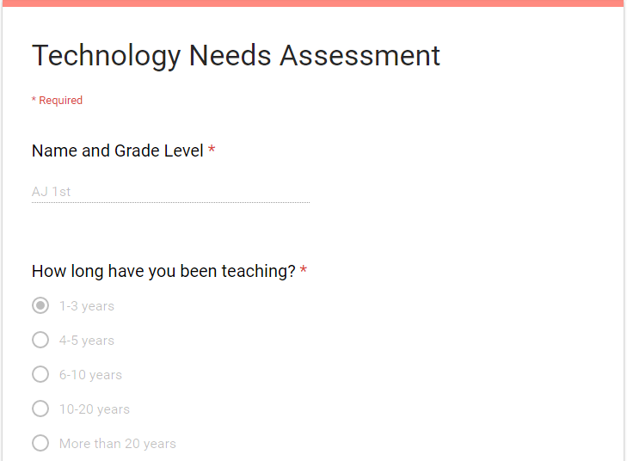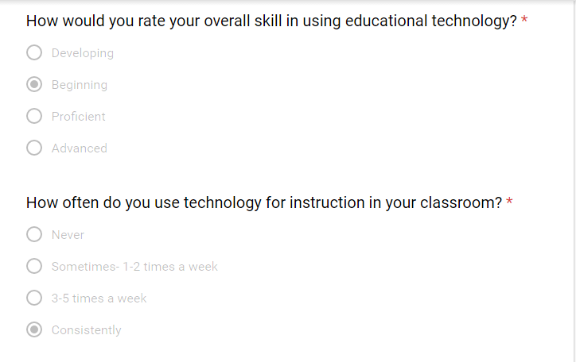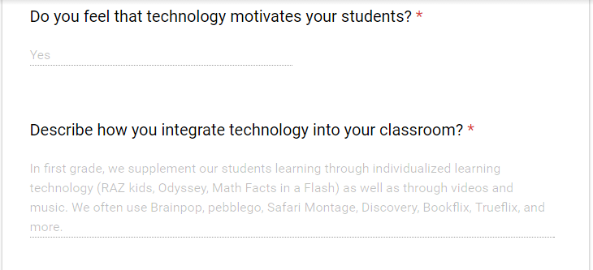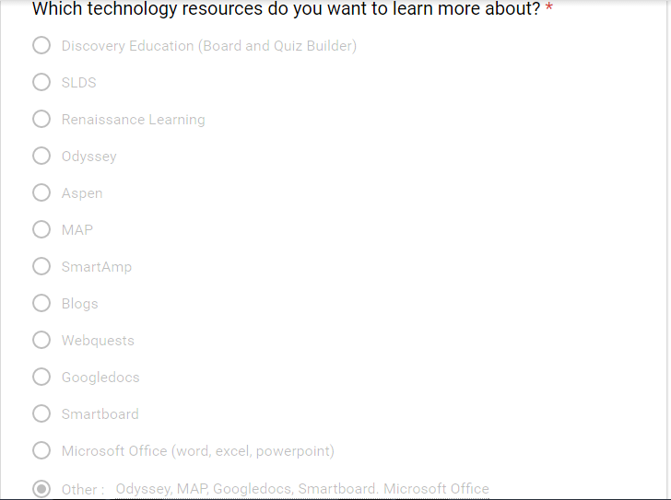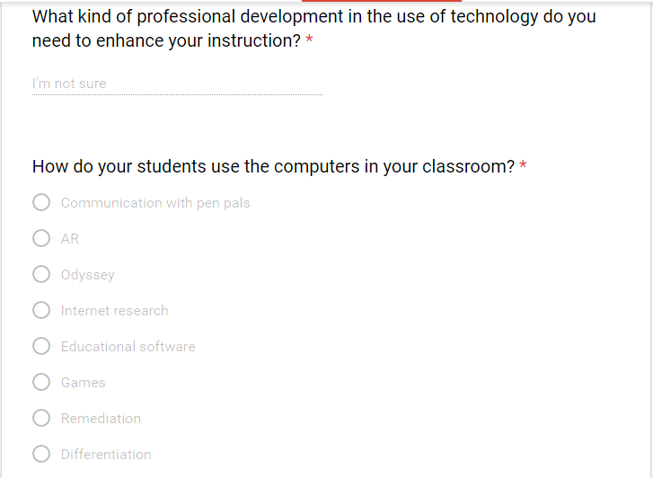

References
Ramey, K. (2013, December 19). Barriers to the Effective Use of Technology In Education. Techucation. Retrieved from http://www.useoftechnology.com/barriers-effective- technology-education/

